Standard Operating Procedure
Standard Operating Procedure for draft development.

S.O.P Task
Area: |  | Relevant Risk Assessment
Date: |  | Relevant CoSHH Assessment

Standard PPE Equipment |  |  |  |  |  |  |  | 
Hazards | 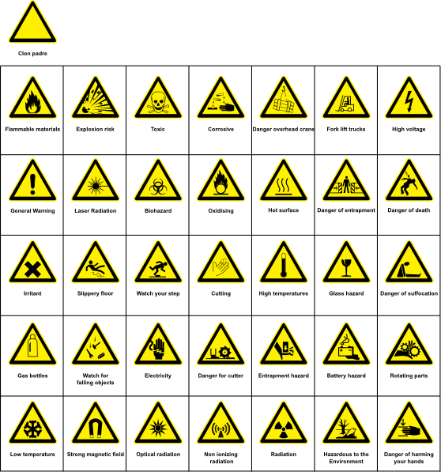
CoSHH | 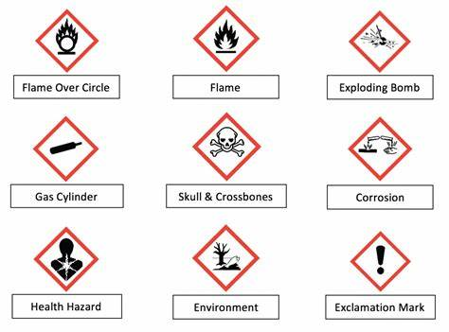
This is the standard operating procedure for:

SOP Written By:

 | SHE – This is the Safety, Health and Environmental elements specific to the step of the task | Additional Notes | Photo taken for step (Y/N) *with photo number*
1
2
3
4
5
6
7
8
9
10

